KCAL Robotics Club
Important Dates:
- Sept. 9th- 8:30 AM Kick-off day (receive kits and game reveal) @
- Meet Every Thursday afterschool room D100
- October 14th – Mall Day (practice session and notebook submission)
- October 21nd – Game Day at Nolan Catholic High School
What is it?
- Boosting Engineering Science & Technology
- Design and build a custom robot from the provided materials
- Create an exhibit, notebook and presentation to highlight your team and the competition theme
- This years’ theme: 2017 Crossfire
Learn
- Teamwork, web design, business promotions, marketing, designing, construction, 3D printing, wiring electronics, mechanisms, programing, and driving skills
More Info
- See Mr. Youngblood or Mrs. Roberts for more information
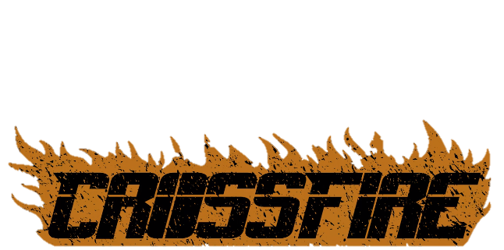
- Informational meeting Aug. 31st at 4:30 in the Tank
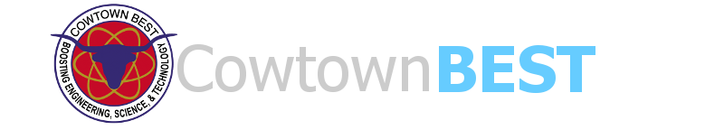
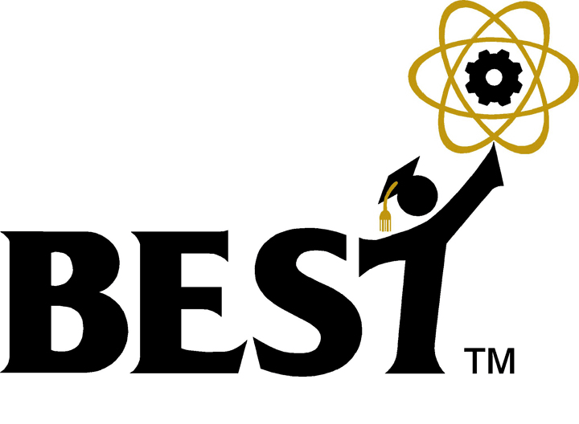
- www.bestinc.org

